**Excel Project**

**Data**

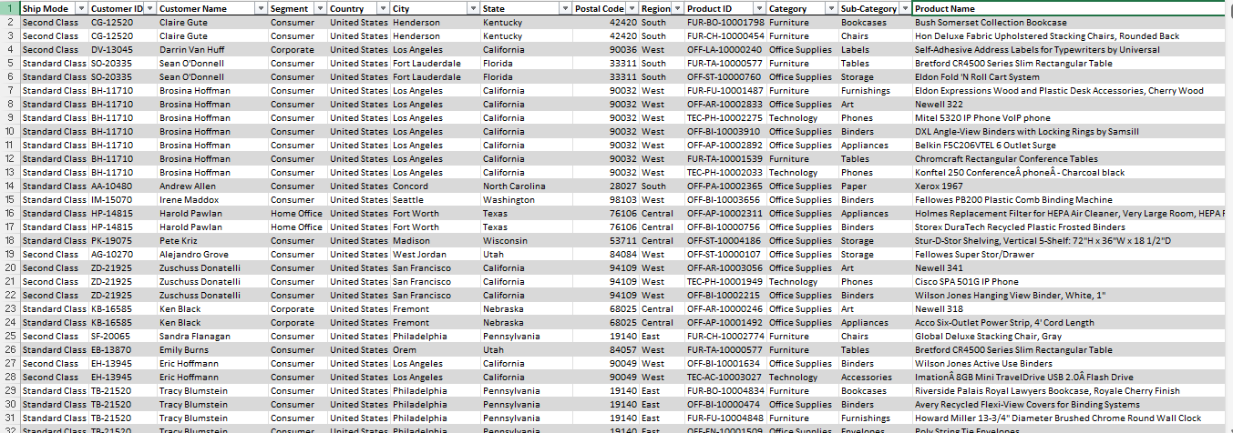

Fig1: Data for analysis

Source: Self-created with MS-Excel

**Pivot_table number 1**

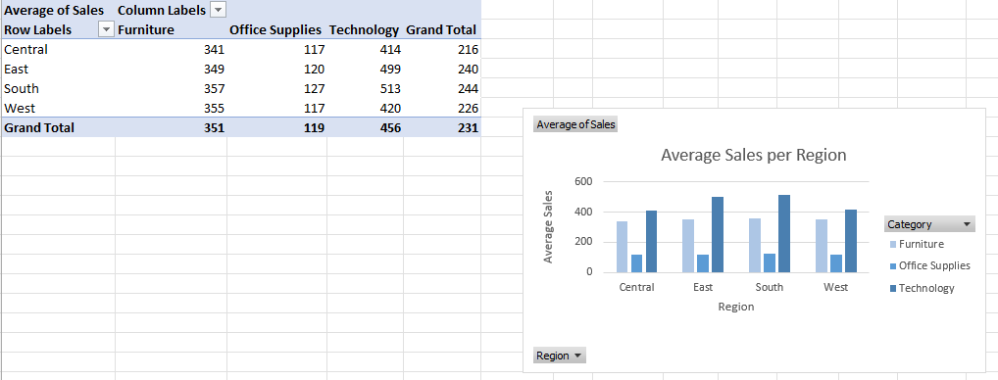

Fig 2: Average sales in each category based on regions

Source: Self-created with MS-Excel

**Pivot_table number 2**

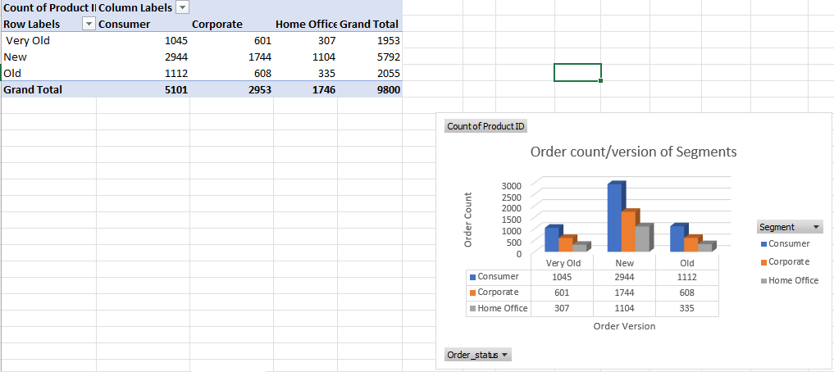

Fig 3: Order count in each version and segments

Source: Self-created with MS-Excel

**Pivot_table number 3**

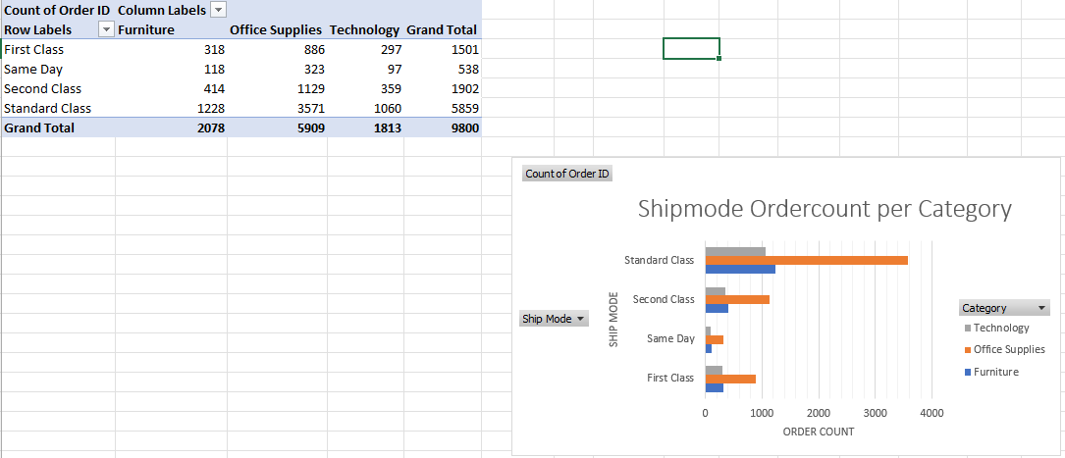

Fig 4: Order count for every ship mode and category

Source: Self-created with MS-Excel

**Dashboard**

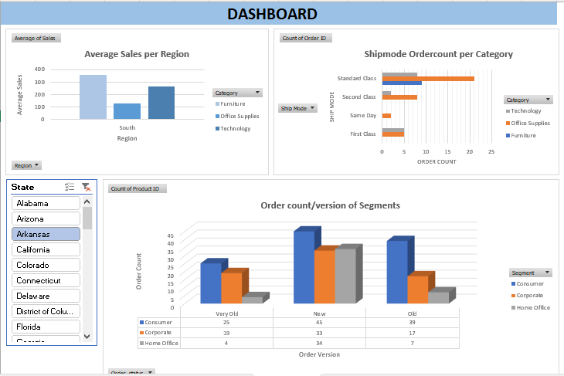

Fig 5: Final dashboard with filter

Source: Self-created with MS-Excel